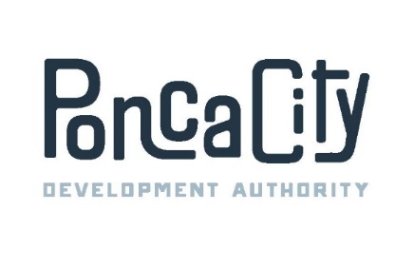

PONCA CITY DEVELOPMENT AUTHORITY
SPECIAL MEETING AGENDA
07/20/2023 7:30 A.M.
400 East Central, Ponca City, OK
City Central Building
Suite 100 – James McNeese Gallery-South Lobby

The Government of the City of Ponca City encourages participation in city activities by all interested persons. If your participation at this meeting is not possible due to a disability, please notify personnel in the Ponca City Development Authority office, 400 East Central, Ste. 200, 580-765-7070, prior to the above listed meeting time so any necessary arrangements can be made.

Official action can only be taken on items which appear on the agenda. The public body may adopt, approve, ratify, deny, defer, recommend, amend, strike or continue any agenda item. When more information is needed to act on an item, the public body may refer the matter to PCDA staff or a board committee if appropriate. Under certain circumstances, items are deferred to a specific date or stricken from the agenda entirely.

- Call to order;

- Attendance roll call and recognition of guests;

- Public Comment.

- Consent Calendar. (All items shall be considered and voted upon together unless an item is pulled for discussion or separate consideration at the request of one or more Trustees.)

  - Consider and Vote upon the minutes from the regular meeting on June 8, 2023;

  - Consider and vote on the minutes of the special meeting held on June 28, 2023;

  - Consider and Vote upon the Financial Reports for June, 2023;

  - Consider and Vote upon the Payment of Claims for June, 2023;

- Update on Construction Projects;

- Staff Reports;

- Entertain a motion to enter into executive session pursuant to Title 25, Section 307 Oklahoma Statutes to discuss projects 23-03, 23-06, 23-07, 23-08, Blue Falcon, BRT, Elevate, Dawns, Feeder, as well as a potential real estate transaction involving property located at the southwest corner of Waverly and Sykes Boulevard.

- New Business;

- Entertain a motion to adjourn.

