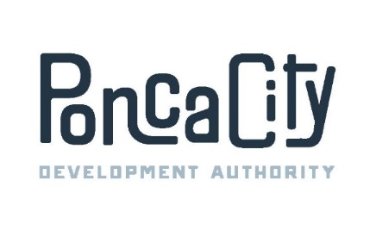
PONCA CITY DEVELOPMENT AUTHORITY
REGULAR MEETING AGENDA
06/08/2023 7:30 A.M.
400 East Central, Ponca City, OK
City Central Building
Suite 101, The James McNeese Gallery-First Floor-South Lobby

The Government of the City of Ponca City encourages participation in city activities by all interested persons. If your participation at this meeting is not possible due to a disability, please notify personnel in the Ponca City Development Authority office, 400 East Central, Ste. 200, 580-765-7070, prior to the above listed meeting time so any necessary arrangements can be made.

Official action can only be taken on items which appear on the agenda. The public body may adopt, approve, ratify, deny, defer, recommend, amend, strike or continue any agenda item. When more information is needed to act on an item, the public body may refer the matter to PCDA staff or a board committee if appropriate. Under certain circumstances, items are deferred to a specific date or stricken from the agenda entirely.

- Call to order;

- Attendance roll call and recognition of guests;

- Public Comment.

- Consent Calendar. (All items shall be considered and voted upon together unless an item is pulled for discussion or separate consideration at the request of one or more Trustees.)

  - Consider and Vote upon the minutes from the regular meeting on May 11, 2023;

  - Consider and Vote upon the Financial Reports for May, 2023;

  - Consider and Vote upon the Payment of Claims for May, 2023;

- Consideration and possible action on approving Change Order Number Six to the Construction Management Contract with Hembree and Hodgson for the “Duke” spec building in the amount of $18,505.45;

- Update, discussion and direction on the east side Airport Industrial Park drainage project;

- Consideration and possible action on approving a potential expense with BC Coatings in the amount of $13,175 to paint the external, east facing hangar doors at the PCDA-owned hangar at 2501 Waverly;

- Consideration and possible action on approving the draft 2023-2024 PCDA Budget;

- Consideration and possible action on electing PCDA Board officers for the 2023-2024 fiscal year;

- Staff Reports;

- Entertain a motion to enter into executive session pursuant to Title 25, Section 307 Oklahoma Statutes to discuss Projects 21-08, 23-03, 23-07, Albatross, Alpha III, Feeder, KaZa, Thunderbird, Valet and Voicemail, as well as potential real estate transactions involving property located at the southwest corner of Sykes and Hall Boulevard and the PCDA-owned building at 2402 Sykes Boulevard;

- Consideration and possible action on approving an amendment to the lease between Log10, LLC and PCDA to lease with an option to purchase the PCDA-owned building at 2502 Sykes Blvd;

- New Business;

- Entertain a motion to adjourn.

